**In JavaScript there is block level scope and global scope**

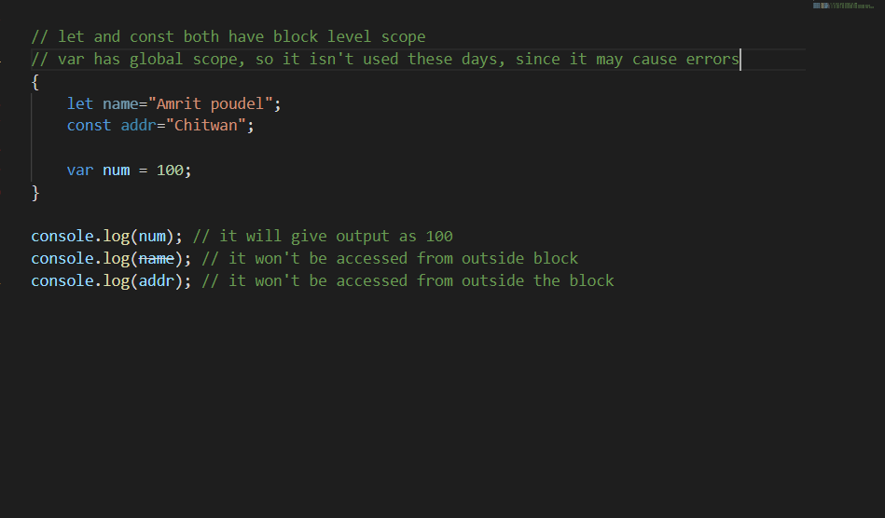

Redeclaring with let is not allowed

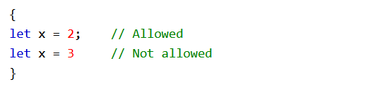

But reassigning with let is allowed

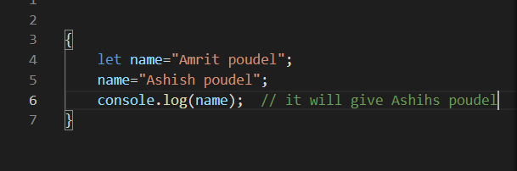

Everything declared by const remains constant throughout the block, we cannot reassign

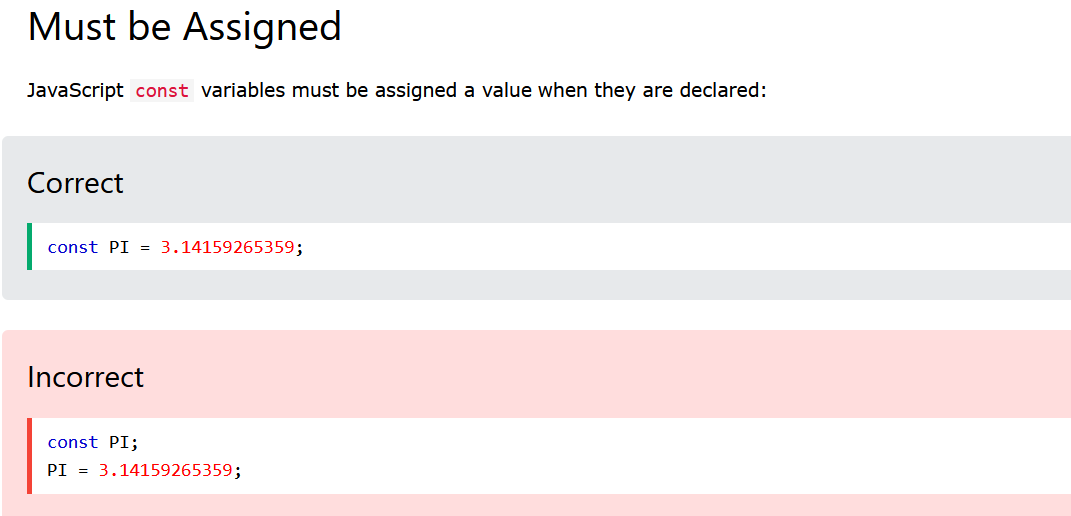

**Deeply about const**

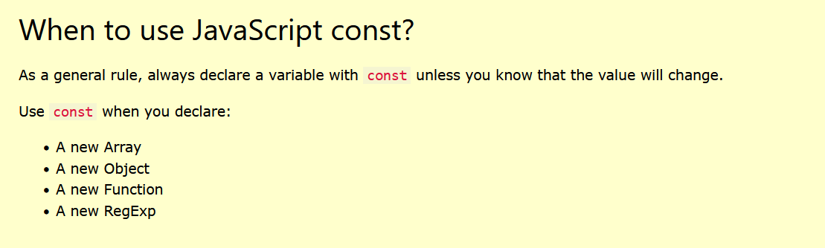

actually when we do

const num = 100;

what happens is a memory is created for 100, and by using const that memory address, that reference to 100 becomes constant, so when we try to reassign num with others it doesnot happens



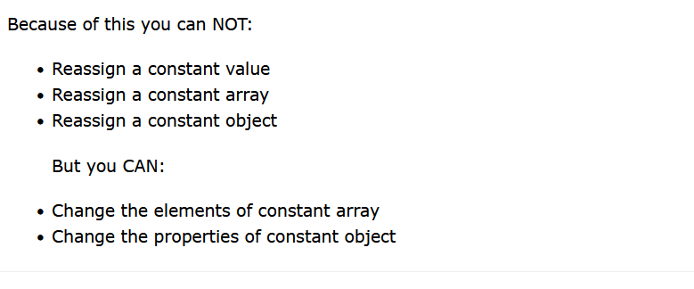

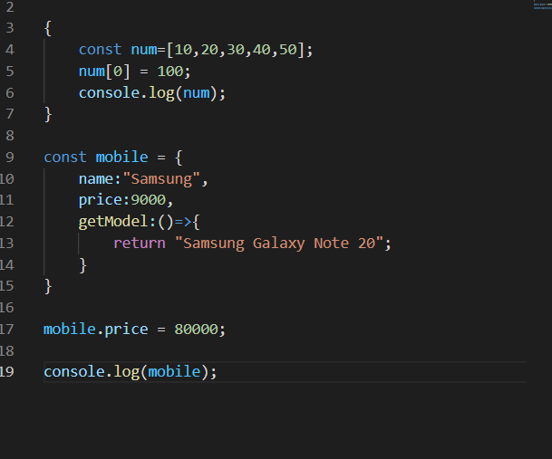

Like this we can change elements of const array and properties of const objects

BUT AGAIN REASSIGNING IS NOT ALLOWED